PanAway Essential Oil

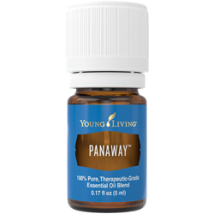
Apply PanAway® after exercise or to the neck and back anytime for a soothing and stimulating aromatic experience.
EarthKosher Certified

How to Use
Dilute and apply topically on location as needed or use in a massage.
Caution: Keep out of reach of children. For external use only. Keep away from eyes and mucous membranes. If you are pregnant, nursing, taking medication, or have a medical condition, consult a health professional prior to use. Not intended for children under the age of 6 without the advice of a health professional.

Ingredients
Gaultheria procumbens† (Wintergreen) leaf oil, Helichrysum italicum† flower oil, Eugenia caryophyllus† (Clove) bud oil, Mentha piperita† (Peppermint) oil
†100% pure, therapeutic-grade essential oil

