Peppermint Essential Oil
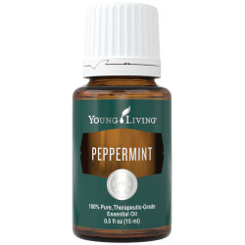
Fresh, nostalgic, and instantly recognizable, Peppermint essential oil’s scent invigorates the mind and senses, while inspiring a sense of peace. Used topically, Peppermint oil creates a cool, tingling sensation on the skin, making it a favorite for sports massage and an important part of Young Living’s Raindrop Technique®.
When your day is dragging—through a workout, class, or day at work—enjoy some Peppermint oil benefits by applying it to your head and neck. The refreshing aroma will give you a boost of positivity! Peppermint is also a great option for diffusing on its own or with compatible scents such as Lavender, Rosemary, Spearmint, or Sage!
Peppermint is a key ingredient in PanAway®, AromaEase®, Aroma Siez™, Relieve It™, and Deep Relief™ Roll-On essential oil blends.

Peppermint uses:
- After a tough workout, dilute a few drops of Peppermint in V-6™ Vegetable Oil Complex, and use it in a refreshing post-workout massage.
- Create your own home spa! Add Peppermint and Eucalyptus Radiata to hot bath water and enjoy the relaxing, invigorating scent and aromatic steam.
- Peppermint is in the same family as both Lavender and Rosemary. Diffuse the oils of these powerful botanicals together for a fresh aroma that uplifts the spirit.
EarthKosher Certified

How to Use
Diffuse, directly inhale, or apply topically.
Caution: Keep out of reach of children. If you are pregnant, nursing, taking medication, or have a medical condition, consult a health professional prior to use. Not intended for use with infants.
Storage: Keep in a cool, dark place.

Ingredients
Peppermint (Mentha piperita)† leaf oil
† 100% pure, therapeutic-grade essential oil

