Young Living’s Stress Away essential oil blend is a solution created from natural elements that combine stress-reducing and relaxing properties. With vanilla and lime as central components, Stress Away also features copaiba and lavender, which are known to reduce mental rigidity. Using Stress Away regularly can lead to a more balanced mentality, restoring your equilibrium and creating a calming effect. There are a lot of everyday, simple applications for Stress Away essential oil, so you don’t have to spend a ton of time or effort introducing it into your life. Here are some examples to get you started.

1. Mood Lifting Drinks – Add a few drops of Stress Away to your water while working for a calming effect on nervous tension.

2. Headache relief – Use the roll-on applicator to roll Stress Away on the back of your wrists, forehead and/or temples. It can relieve the tired; achiness stress creates in all of your muscles.

3. Reed Diffuser Replacement Oil – You can easily make your own replacement oil for a reed diffuser. All you need is some Stress Away oil, distilled water and a bit of rubbing alcohol.
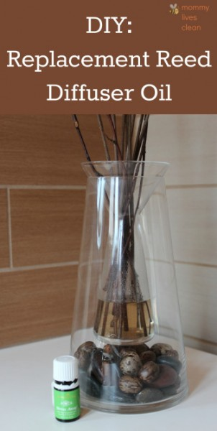

4. Unwind aromatically – Diffuse a few drops of Stress Away combined with a few drops of Peppermint to unwind and uplift after a stressful day.

5. Bath Soak – Add 10 drops of Stress Away to 2 cups of epsom salt. Place this in a warm bath and soak for 20 minutes to relieve stress.

6. Promote better sleep – Put 8 drops of Stress Away with 4 drops of lavender in a diffuser. Use in your bedroom in the evening to promote healthy, more restful sleep.

7. Sugar Scrub – Make this Vanilla Lime Sugar Scrub and scrub your stress and worries away in the shower or bath!
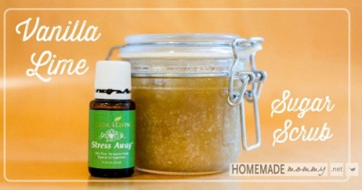

8. Calming Cologne – Rub a few drops into your wrists to induce more confident feelings throughout the day. Plus, it will smell great!

9. Topical application – Rub a drop of Stress Away onto your temples and to the back of your neck to ease tension. Your muscles will feel more relaxed.

10. Teeth Grinding Remedy – Dilute 1-2 drops with coconut or olive oil and rub along your jawline. Your jaw will relax leading to less clenching and grinding.

11. Car Freshener (and relaxer!) – Put a few drops of Stress Away on cotton balls and place them in the slats of your car vents. Turn on the fan to diffuse the freshener throughout the car so everyone riding or driving can benefit!
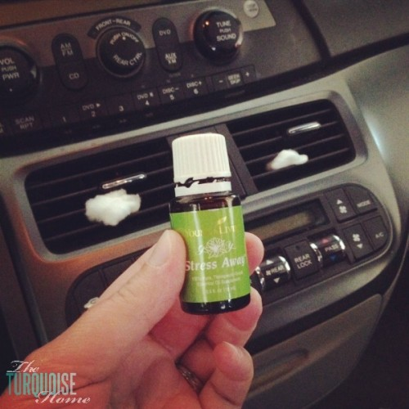

12. Sore neck relief – Roll on Stress Away when you have neck pain – just a quick swipe across the back of your neck. The tension will ease, relieving the stiffness and soreness.

13. Foot cramp relief – Rub just a few drops of Stress Away over the top and bottom of your foot to relax the tension in your cramping muscles. Once relaxed, the pain will subside.

14. Stress Relief Spritz – Mix up some Stress Away with peppermint and distilled water. Put it in a glass spray bottle and spritz it on when you feel anxious or stressed out.

15. Sleep-Spray – Combine oils that you and your kids find relaxing and spray them on pillows for bedtime or nap time! Stress Away is a great idea for this; combined with lavender it’ll calm kids right down and have them snoozing worry-free.
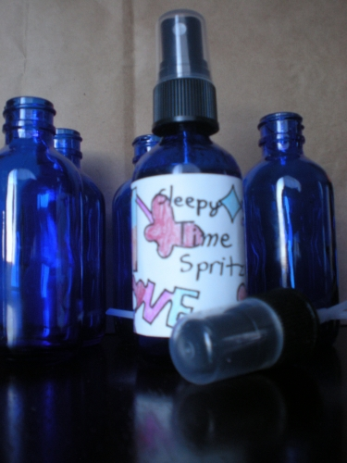

16. Homemade Stress Reducing Deodorant – Use Stress Away when making your own deodorant. It’s all natural and the lime and vanilla in Stress Away smells amazing. Plus, you’ll have the calming effects of stress away with you all day long!

17. Back pain relief – Use the roller application on your lower or upper back, wherever you have knots and tension. Stress Away oil will relax your muscles and help ease pain.

18. Stress-Away Fidget Balls – If your kids have trouble focusing and are wound up with nervous energy, try this helpful DIY using Stress Away oil.

19. PMS relief – You can apply Stress Away to your wrists and temples daily, or you can use it just when needed. It’ll soothe symptoms of PMS and can even reduce related headaches and cramps.

20. Refreshing Fruit Salad – Slice up some fruit and create a splash of “dressing” for the salad with some white wine and Stress Away! It’s delicious, but even better? It’ll restore some much needed equilibrium and mental balance.

21. Whipped Body Butter – Use Stress Away and other favorite essential oils in this recipe for whipped body butter. It’ll replace your daily moisturizer and keep your body hydrated while you soak in the benefits of reduced anxiousness, nervousness and tension.
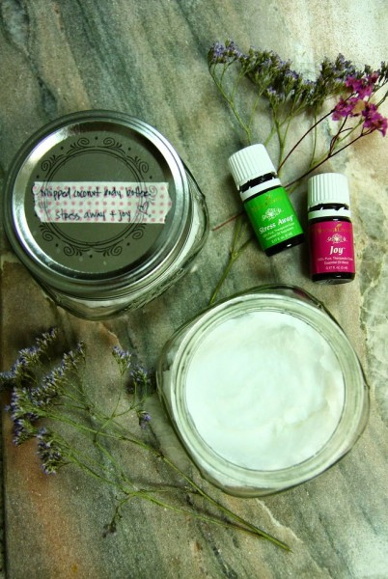

22. Bath Salts – Create your own bath salts with Stress Away! You’ll have a spa-like soak, and your mood will be lifted.

23. Mood Lifting Room Spray – Create an aromatic room spray that smells delicious and causes happiness! Just mix Epsom salts, distilled water and Stress Away and spray around your home for a mood enhancing, stress-relieving, feel-good air freshener.

24. Stressed pet help – If you’re traveling with pets, you know they can become fearful, anxious and stressed out. Calm your pets while driving to the vet, flying to vacation, or simply when they’re anxious at home. Dilute in carrier oil and apply one drop onto the front paws. Or place several drops onto a scrap of cotton fabric and keep it in their pet carrier or kennel.

25. Stress-Away Candles – Make your own stress relief candles with beeswax and essential oils. They not difficult, and can be personalized by adding other oil scents along with Stress Away.

