Stress Away Essential Oil

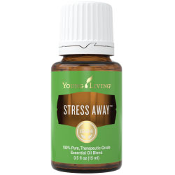

Stress Away™ is the first product to contain the unique combination of Lime and Vanilla pure, therapeutic-grade essential oils. With an aroma that is the perfect blend of tropical and citrus, Stress Away is uniquely relaxing and comforting.

How to Use
Diffuse, inhale directly, or dilute with V-6 Vegetable Oil Complex and apply topically.
Caution: Keep out of reach of children. If you are pregnant, nursing, taking medication, or have a medical condition, consult a health professional prior to use. Possible skin sensitivity. Avoid direct sunlight and UV rays for up to 12 hours after application
Storage: Keep in a cool, dark place.

Ingredients
Copaiba (Copaifera reticulata), Lime (Citrus aurantifolia), Cedarwood (Cedrus atlantica), Vanilla (Vanilla planifolia), Ocotea (Ocotea quixos), Lavender (Lavandula angustifolia)

